Exp No: 2 Implement programs for visualizing time series data.

**Aim:** To implement programs for visualizing time series data.

**Code:**

import pandas as pd

import matplotlib.pyplot as plt import seaborn as sns

import numpy as np

from mpl_toolkits.mplot3d import Axes3D

file_path = r"C:\Users\Lenovo\Downloads\coin_Solana.csv"

df = pd.read_csv(file_path)

df['Date'] = pd.to_datetime(df['Date'])

df = df.sort_values(by='Date')

**Visualization 1: 3D Bar Chart for Closing Price Distribution**

closing_price_ranges = ["Low (<25%)", "Mid (25-75%)", "High (>75%)"]

percentiles = np.percentile(df['Close'], [25, 75]) labels =[]

for price in df['Close']:

if price < percentiles[0]:

labels.append(closing_price_ranges[0]) elif price > percentiles[1]:

labels.append(closing_price_ranges[2]) else:

labels.append(closing_price_ranges[1])

unique_labels, counts = np.unique(labels, return_counts=True)

fig = plt.figure(figsize=(8, 8))

ax = fig.add_subplot(111, projection='3d')

ax.bar(unique_labels, counts, zs=0, zdir='y', alpha=0.8) ax.set_xlabel("Price Category") ax.set_ylabel("Frequency")

ax.set_zlabel("Count")

ax.set_title("3D Bar Chart of Solana Closing Price Distribution") plt.show()

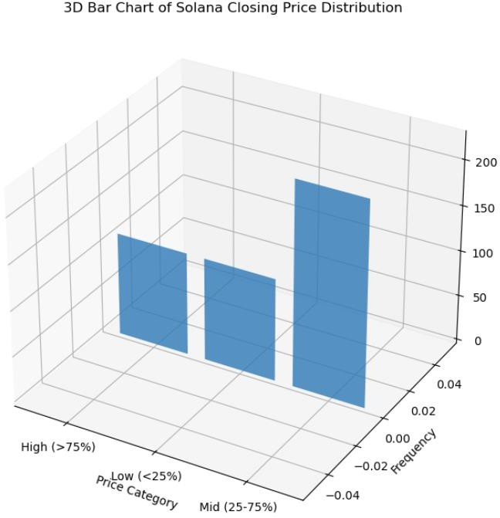**OUTPUT:**

**Visualization 2: Box Plot for OHLC Prices**

plt.figure(figsize=(10, 6))

sns.boxplot(data=df[['Open', 'High', 'Low', 'Close']], palette="Set2") plt.xlabel("Price Type")

plt.ylabel("Price (USD)")

plt.title("Box Plot of Solana OHLC Prices") plt.grid()

plt.show()

**OUTPUT:**

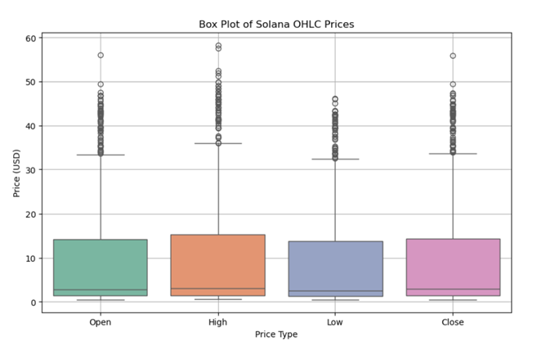

**Visualization 3: Histogram of Closing Prices**

plt.figure(figsize=(10, 5)

sns.histplot(df['Close'], bins=30, kde=True, color='purple') plt.xlabel("Closing Price (USD)")

plt.ylabel("Frequency")

plt.title("Distribution of Solana Closing Prices") plt.grid()

plt.show()

**OUTPUT:**

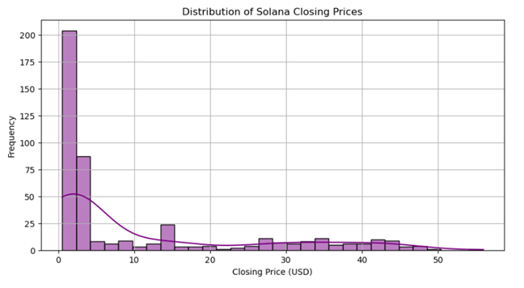

**Visualization 4: Scatter Plot of Volume vs. Closing Price** plt.figure(figsize=(10, 5))

plt.scatter(df['Volume'], df['Close'], alpha=0.5, color='red') plt.xlabel("Trading Volume")

plt.ylabel("Closing Price (USD)") plt.title("Trading Volume vs. Closing Price") plt.xscale('log') # Log scale for better visualization plt.grid()

plt.show()

**OUTPUT:**

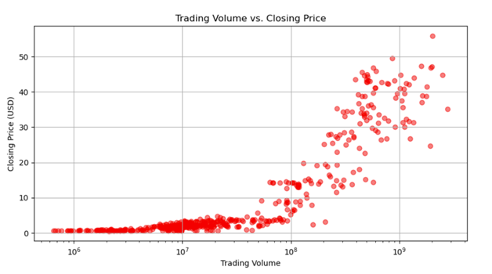

**Visualization 5: Heatmap for Correlation Between Features** plt.figure(figsize=(8, 6))

corr = df[['Open', 'High', 'Low', 'Close', 'Volume']].corr()

sns.heatmap(corr, annot=True, cmap='coolwarm', fmt='.2f', linewidths=0.5) plt.title("Correlation Heatmap of Solana Features")

plt.show()

**OUTPUT:**

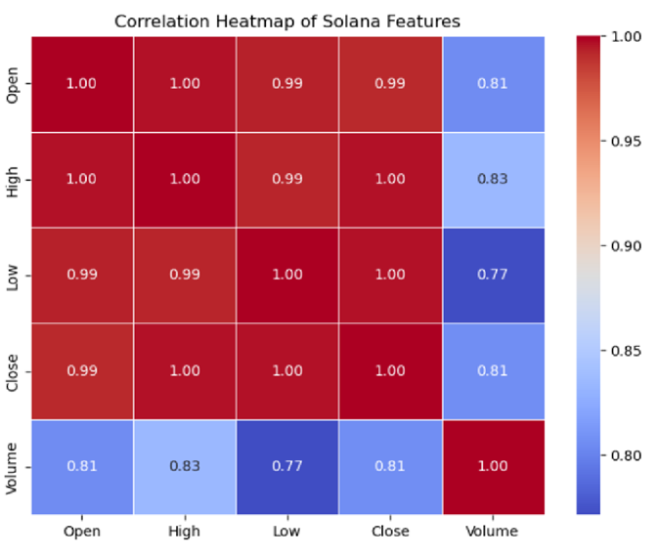

**RESULT:**

The required output is successfully executed for visualizing the data.